Определить точно причину зависания сервера нет возможности так как в IML логе в мы видим только сообщение о перезагрузке сервера с помощью ASR. В операционной системе также нет сообщений о сбое и причине зависания.
Для точной диагностики необходимо в операционной системе настроить сбор дампа Kdump configuration for RHEL:
https://access.redhat.com/site/solutions/6038. После этого в BIOS RBSU отключить ASR.
Во время следующего зависания сервера, необходимо зайти на ILO и нажать кнопку Generate NMI, после чего выполнится сбор дампа kdump. Дамп памяти необходимо поддержке Red Hat для установления причины зависания хоста.

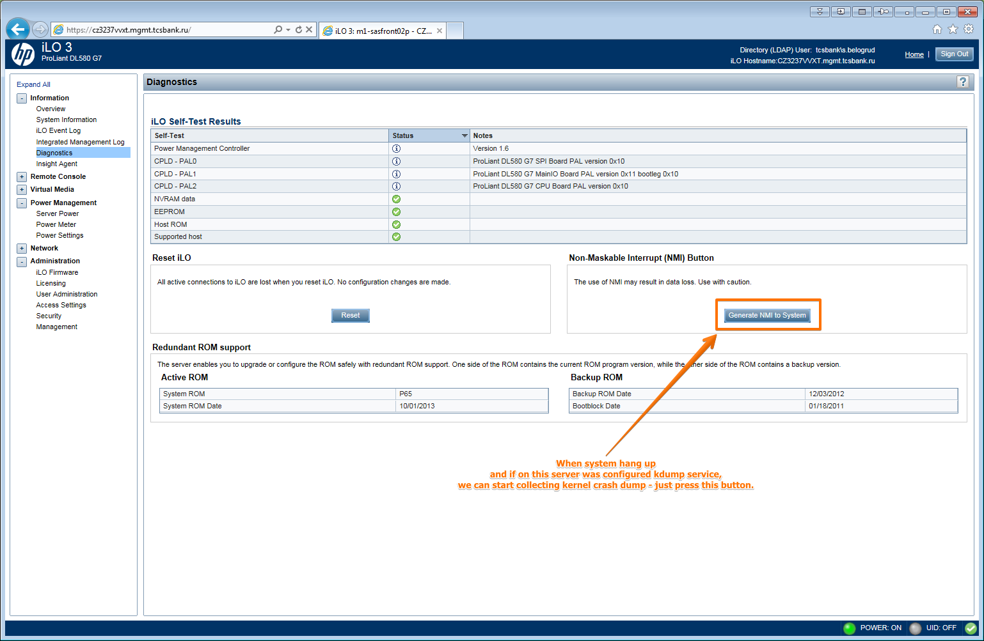

Некоторая информация об ASR:
ASR is a feature that causes the system to restart when a catastrophic operating system error occurs, such as a blue screen, ABEND, or panic. A system fail-safe timer, the ASR timer, starts when the System Management driver, also known as the Health Driver, is loaded. When the operating system is functioning properly, the system periodically resets the timer. However, when the operating system fails, the timer expires and restarts the server.
ASR increases server availability by restarting the server within a specified time after a system hang or shutdown. At the same time, the HP SIM console notifies you by sending a message to a designated pager number that ASR has restarted the system. You can disable ASR from the HP SIM console or through RBSU.

Информация о причинах ASR:
An Automatic Server Recovery (ASR) is not an error on its own, it is a symptom of an error. If a ProLiant server for some reason hangs for more than the ASR timeout period, the ASR mechanism will reboot the server.
When troubleshooting an ASR it is important to look at both the software and the hardware on the server.

Events which may contribute to the operating system locking up include:
• A peripheral device − such as a Peripheral Component Interconnect Specification (PCI) adapter − that generates numerous spurious interrupts when it fails.
• A high priority software application consumes all the available central processing unit (CPU) cycles and does not allow the operating system scheduler to run the ASR timer reset process.
• A software or kernel application consumes all available memory, including the virtual memory space (for example, swap). This may cause the operating system scheduler to cease functioning.
• A critical operating system component, such as a file system, fails and causes the operating system scheduler to cease functioning.
• Any other event besides an ASR timeout that causes a Non-Maskable Interrupt (NMI)

